My name is Pat and I’ve been working closely with an Account Executive and a Sales Engineer at Mixpanel and they have directed me to you in this case. I’m very excited at some of the demonstrations I’ve been shown but I’m becoming a bit apprehensive as my data isn’t as useful as I’d hoped (or *at all*, really).

We’ve been sending some baseline data for our product just to get a picture of what we can expect but what I see is troubling. Our main funnel shows no conversions.

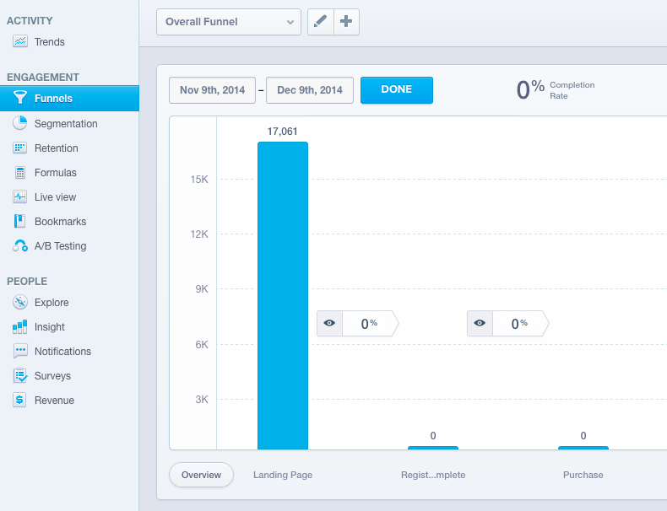

This is weird to me because I see very many of that middle event which happens when a user signs up for our service.

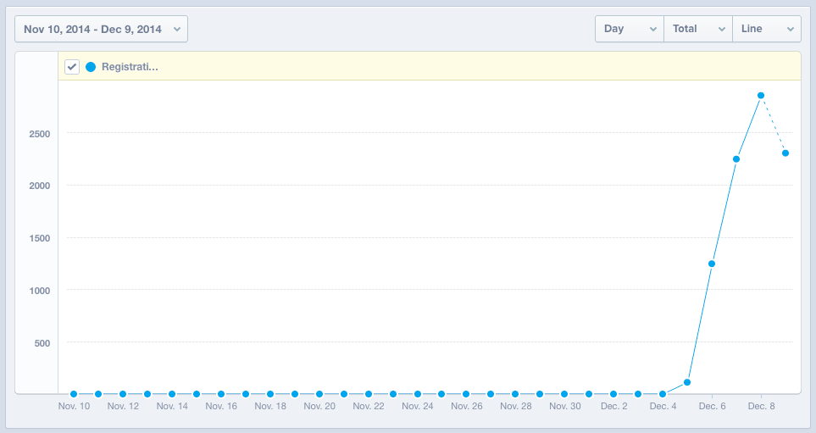

What’s weird though is that I **do** see conversion in this related view, but at a much lower rate than I expect historically.

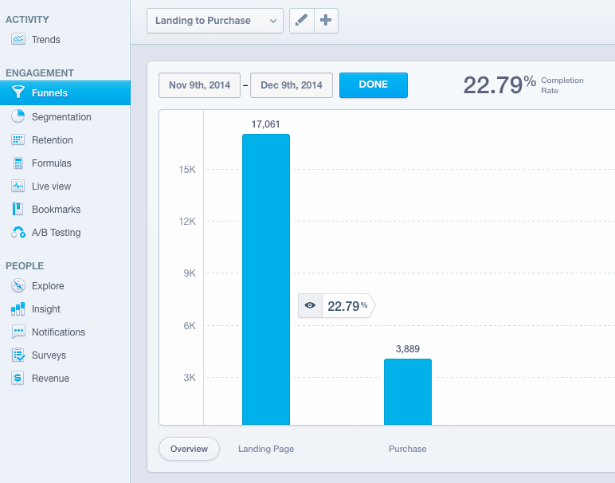

My data is included in a raw csv format and can also be accessed [here in Mixpanel](https://mixpanel.com/report/541955). Please advise on how this gets fixed.

Best,

Pat Davis